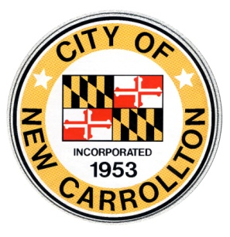**CITY COUNCIL WORKSHOP MEETING AGENDA**

**\*VIRTUAL MEETING\***

MONDAY, FEBRUARY 14, 2022, 7:00 P.M.

**This Agenda is subject to change. If this agenda is modified it will be reposted to the City of New Carrollton’s website:** [**www.newcarrolltonmd.gov**](http://www.newcarrolltonmd.gov)**. If you have any questions please contact the City Clerk at (301) 459-6100.**

|  |  |
| --- | --- |
| **Items for discussion** |  |
| 1. **Call to Order** (5 Minutes) |  |
| 1. **City of New Carrollton Comprehensive Annual Financial Report (CAFR) Fiscal Year ending June 30, 2021 – Ms. Diane Mock** (15 Minutes) 2. **Neighborhood Design Center Presentation** (15 Minutes) 3. **Report of the Mayor and Administration**  (15 Minutes) 4. **Council Questions/Council Announcements** (10 Minutes) 5. **Audio Visual Room RFP Update/Recommendation** (5 Minutes) 6. **Review/Comment on Yearly Proclamations** (10 Minutes) 7. **Meeting Minutes**   a.) Council Workshop/Special Legislative Meeting Minutes (January 6, 2022)  b.) Council Workshop Meeting Minutes (January 19, 2022)  c.) Council Legislative Meeting Minutes (January 20, 2022) (5 Minutes)   1. **Review of Bills**   Batch #1 (January 11, 2022); Batch #2 (January 14, 2022); Batch # 3  (January 24, 2022); and Batch #4 (January 31, 2022); Batch #5 (February 4, 2022)  (5 Minutes)   1. **Public Comment – (Residents’ Concerns, Audience Participation and Phone Calls) When addressing the Council please state your name and address for the record.** (10 Minutes)   (2 Minutes per person)   1. **Request for Future Agenda Items** (5 Minutes) 2. **Adjournment** (1 Minute)     **PLEASE NOTE:** This meeting of the City of New Carrollton Council will be a virtual meeting. Anyone interested in listening to the meeting will be able to by calling the following number: **301-715-8592 with code 843 7028 6209**. You do not need a participant code.  If you want to join the meeting via the Computer click on the link Join Zoom Meeting <https://us06web.zoom.us/j/84370286209> Meeting ID: 843 7028 6209If you have comments for the Council please email them to City Administrative Officer Latasha Gatling at [lgatling@newcarrolltonmd.gov](mailto:lgatling@newcarrolltonmd.gov) by 3:00 p.m. the day of the meeting. |  |